**Hussein Abdulaziz Ebrahim Ahmed**

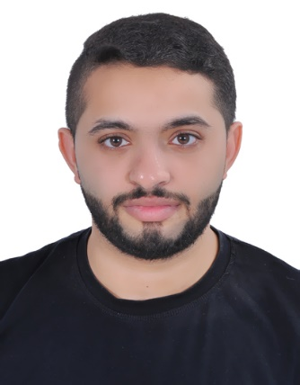**House 155 , Road 1403, Block 1214, Hamad Town, Bahrain**

**Mobile: +973 37774429**

**Email:n.em@Hotmail.com**

**Personal Details**

**Nationality: Bahraini**

**Place of Birth: Jidhafs**

**CPR Number: 930903633**

**Passport No.: 1464667**

**Educational Qualification**

**Qualification Received Institute/School From to**

**Secondary School AlJaberyia High school 2013**

**Experience**

**Company Position Period**

**Health Ministry Mechanic training**

**Jawad group Sales assistant 2 months**

**Abu Dawood Alsaffar Merchandiser 2 years**

**BMMI Merchandiser 3 months**

**G4S Security 7 months**

**Additional Skills**

* **Interpersonal: work under pressure, good communication skills, typing skills.**
* **Languages :Arabic**
* **Computer: Microsoft office and all system programs related to it.**
* **Using FIFO method to display goods.**
* **Arranging floor display.**
* **Knowing market route (Class B,C,A).**
* **Driving license holder.**
* **I have a training certificate in security training school GTS**